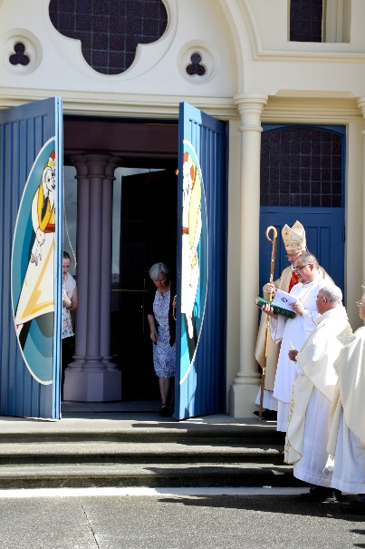
OPENINGS: The Jubilee Doors….
The Holy Doors for the Jubilee are open, and the pilgrims are arriving walking through the doors and reflecting on the call to life a life of Mercy.
This week we start one of the earliest Lenten seasons possible. We are called to walk, to repent, to see and follow the Lord, and to pray, fast and act in Mercy.
The door is opened for each of us to start this Extraordinary Jubilee of Mercy in a Lent of turn around, or metanoia!
Join a Caritas reflection group, the material is wonderful, focused on the Scriptures and the call to Mercy and action.
Pray the windows of Mercy at the Cathedral, come on pilgrimage or visit www.pndiocese.org.nz/mercy and click the links to experience the Parables of Mercy as told through the Cathedral’s windows.

FOCUS: Corporal Works of Mercy – Feed the hungry
Three calls for this month:
- Give something each Sunday to Vincent de Paul: real food !
- Each week of Lent invite a stranger, a shut in, an elderly member of the parish/ relative, the neighbour for a meal (the hunger may be for company or to be seen).
- Give to Caritas to feed the 60% of the world who literally are hungry!
It is simple, it just is the call to actually make our words into actions!
PILGRIMAGE: to the Holy Doors

Pope Francis has asked, as part of the Jubilee Year celebrations that a Holy Door be set aside for pilgrimage in the diocesan Cathedral. You are invited to journey from your homes, parishes, schools and colleges, passing through the Holy Doors of the Jubilee of Mercy at the Cathedral and be inspired to make acts of mercy daily. Everyone is invited by Bishop Charles and the Cathedral Parish to make a pilgrimage to the Cathedral and through the Holy Doors during the Jubilee of Mercy. Individuals will be able to make a pilgrimage visit any day!!

From +Charles:
“Central to the Jubilee Year is the experience of being a pilgrim and passing through a Holy Door (every Cathedral in the world will have one). During the year, school and parish pilgrim groups will come to our magnificent Cathedral of the Holy Spirit in Palmerston North. It is your holy place. You will be spiritually renewed and inspired by your visit.
Some ask what differences will this make. In one sense that is over to you. But if you step through the holy door with a desire to be renewed and to realign your life – especially your attitudes towards those who struggle – with God’s vision for us, you will indeed leave strengthened in your resolve to give a hand, your hand, to those in need.”

Book your parish or school groups times: 06 357 2891 or visit www.pncathedral.org.nz
Links to Resources
www.pn.catholic.org.nz/mercy
The Diocesan site with many resources for prayer and ideas for action, dates and how to make a pilgrimage. Look out for the hymns of mercy that have been added there.
Newsletter/Bulletin Notices

Week ending February 07
Celebrating the Jubilee of Mercy:
Do not be afraid; I have called you, by name, and I am sending you. This is the call of the Jubilee of Mercy, but more this is the call of our baptism. We prepare for Lent and Easter, and moving in the Jubilee of Mercy. You are unique in what you are called to be and do, do not be afraid, rather know that in your gift you are being sent, to feed, to teach, to visit, to pray. Let us follow Him on the Way of Life.
Week ending February 14
Celebrating the Jubilee of Mercy:
It can’t be me or us! It must be the ‘chosen’ people. The chosen people are us, the poor, the weak, the ones who know it is only the love and life of God that gives us strength and direction. In our parish in our school, stand up and serve; pray and know that it is the love of God and neighbour that makes us real and alive. Just do it, is the call to everyone to be part of the Way of the Lord
Week ending February 21
Celebrating the Jubilee of Mercy:
The Way of mercy and the Lord starts in prayer, going aside to pray. Not alone, with the lord, and our brothers and sisters. Prayer to share the joy and sadness of the day at the dinner table; prayer as we tuck the little ones into bed, prayer by dropping into Church on our way to or from school or work; but also: the prayer on the Mountain didn’t stop there, they came down knowing they had been called to walk the Way of the Lord.
Week ending February 28
Celebrating the Jubilee of Mercy:
It is never too late to walk the way of the Lord and bear fruit; but where should I look to serve and see the Lord revealed. Moses is a great example today, doing his daily work, he saw the place where the Lord was revealed and where he was called to respond. Go to work today and open your eyes to the place, the person where the Lord is calling you to see and respond to the way of the Lord.

Major Events

- Ash Wednesday – 10 February
- Election of the Catechumen at the Cathedral – 21 February
- 24 Hours with the Lord – 4-5 March
- Mass of Chrism - 22 March
- Triduum of the Lords Passion, Death and Resurrection - 24-27 March
- Caritas Challenge -1-2 April

