THROW OPEN THE
HUAKINA
TE KŪAHA O TE ATAWHAI
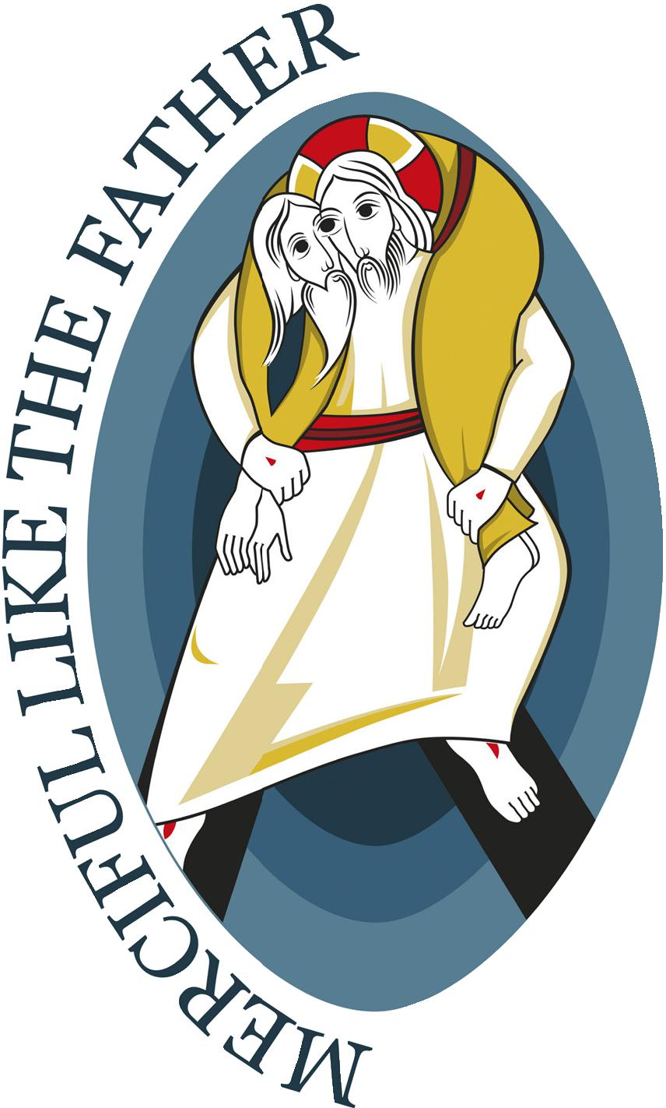
DOOR OF MERCY

Rite of the Opening of the Door of Mercy
Te Ritenga Whakatuwhera i te Kūaha o te Atawhai

December 08th 2015
Feast of the Immaculate Conception

Introduction

Today, the 50th anniversary of the closing of the Second Vatican Council, Pope Francis will open, at St Peter’s in Rome, the Holy Door, and inaugurate the Jubilee of Mercy.

He has asked the whole Church to pray with him on this day. And next Sunday, the 13th of December he has asked that every Cathedral in the world would open its own Holy Door, and asks us church to go on pilgrimage, and to recommit our lives to the mercy and love of God, and to actively bring that mercy in word and deed to our world.

So during Mass this morning let us, following the example of Mary, hear the Word of God, and say “Yes, Let your will be done”, and bring the Christ to birth in our world, in the words and deeds of our lives as individuals and as the Body of Christ, the Church.

Some suggested additions to the Mass of the Immaculate Conception

Penitential Rite
Priest:
Blessed are you, Father:
you alone have done great things for us.
The people reply:
P. Your mercy endures forever.

Priest:
Blessed are you, only begotten Son:
you have freed us from our sins with your blood.
The people reply:
P. Your mercy endures forever.

Priest:
Blessed are you, Holy Spirit:
consoler of the soul and its most soothing relief.
The people reply:
P. Your mercy endures forever

Prayer
Priest:
My brothers and sisters,
during this Extraordinary Year of Jubilee
we shall listen joyfully to the Gospel of Mercy
that Jesus Christ
continually proclaims to all creation,
inviting us to rejoice in his abundant love
and mercy which endures forever.
P. Amen

The Mass is the Mass of the Immaculate Conception

We suggest the addition of a recitation of the Prayer for the Year of Jubilee at the:

Prayers of the Faithful:

Shortened form of Pope Francis’ Prayer, for use in every prayer of the faithful during the Jubilee of Mercy

Lord Jesus Christ,
You have taught us that whoever sees you sees the Father,
and that whenever we see and serve the poor, the naked, the thirsty, the hungry, the imprisoned, we see and serve you.

You are the visible face of the invisible God, the God of forgiveness and mercy:
Lord, Show us your face and we will be saved.

Let us, your Church, be your visible face in the world, the presence of our Lord risen and glorified.
Let us through this Jubilee of Mercy accept that we need to be clothed in weakness
so that we may feel compassion for those in need:
let everyone who approaches us feel sought after, loved, and forgiven by God.

Send us your Spirit so every one of us will be anointed
and this Jubilee of Mercy will be a year of grace from the Lord,
and we your Church, with renewed enthusiasm, will bring good news to the poor,
proclaim liberty to captives and the oppressed,
and restore sight to the blind.

We ask this of you, Lord Jesus, who live and reign with the Father and the Holy Spirit for ever and ever.
Amen.

Sunday December 13th 2015

(The Mass is the Mass of the 3rd Sunday of Advent, with its readings and prayers, the following are some suggestions based on the Liturgy of opening a Holy Door, which will be celebrated by Bishop Charles at the Cathedral of the Holy Spirit at 9-30 am)

It is suggested that there could be a rite of entry, as on Palm Sunday, which would mean that the people gather outside the Church and there is a greeting, and then a solemn procession into the Church.

Procession into the Church

Gathering at the Door of the Church

When all are ready, trumpets (or conchs) call the faithful to worship.

The Priest greets the faithful and invites them to make a procession/hīkoi into the Church saying:

We are God’s holy people.
The people reply:
P. We are his Church.

Priest:
We are a pilgrim people.
The people reply:
P. We walk in the footsteps of Christ.

Priest
Let us go forth in the name of Christ.
The people reply:
P. He is the Way, the Truth and the Life!
He walks with us in this Year of Mercy!

Sign of the Cross and Greeting

The priest then says:
Priest:
Ki te ingoa o te Matua, o te Tamaiti,
o te Wairua Tapu.
R. Āmene.

He then greets the people with these words:

Kia tau iho ki a koutou te atawhai o te Matua,
te rongomau o to tātou Ariki o Hēhu Karaiti
me te whiwhinga tahitanga ki te Wairua Tapu.
R. Ki tōu wairua anō hoki.

[The mercy of the Father,
the peace of our Lord Jesus Christ,
and the communion of the Holy Spirit
be with you all.
R. And with your spirit.]

Praise of God

The Priest invites the faithful to bless and praise God:
Glory to you, Father, who forgive our faults
and heal our infirmities.
R. Your mercy endures forever.

Glory to you, Lord, merciful and kind,
slow to anger and abounding in mercy.
R. Your mercy endures forever.

Glory to you, Lord; you who are a tender Father
toward your children.
R. Your mercy endures forever.

SOLEMN PROCLAMATION OF THE BULL OF INDICTION:
Misericordiae Vultus – The Face of Mercy

Exhortation
Priest:

Dearly beloved brothers and sisters,
with eyes fixed on Jesus and his merciful face,
the Holy Father, Francis
on the Solemnity of the Immaculate Conception,
inaugurated this Extraordinary Jubilee.

Today in Palmerston North Bishop Charles will ‘throw open’ a Door of Mercy
let us listen to the words of Pope Francis
as he exhorts the Universal Church
to gaze upon the Face of Jesus, the Face of Mercy.

Proclamation
Bull of Indiction of the Extraordinary Jubilee.

Deacon or Reader 1:
“Jesus Christ is the face of the Father’s mercy.”
Reader 2:
These words might well sum up the mystery of the Christian faith. Mercy has become living and visible in Jesus of Nazareth.
Deacon or Reader 1:
“Rich in mercy ... slow to anger, and abounding in steadfast love and faithfulness.”
Reader 2:
The Father has never ceased to show,
in various ways throughout history,
his divine nature.
In the “fullness of time”,
when everything had been arranged
according to his plan of salvation,
the Father sent his only Son into the world, born of the
Virgin Mary, to reveal his love for us.
Deacon or Reader 1:
“Whoever sees Jesus sees the Father.”

Reader 2:
Jesus of Nazareth, by his words, his actions, and his entire person, reveals the mercy of God.
Deacon or Reader 1:
Mercy:
Reader 2:
The ultimate and supreme act
by which God comes to meet us.
Deacon or Reader 1:
Mercy:
Reader 2:
The fundamental law
that dwells in the heart of every person
who looks sincerely into the eyes
of his brothers and sisters on the path of life.
Deacon or Reader 1:
Mercy:
Reader 2:
The bridge that connects God and us,
opening our hearts to the hope of being loved forever
despite our sinfulness.
Deacon or Reader 1:
At times we are called to gaze
even more attentively on mercy
so that we may become a more effective sign
of the Father’s action in our lives.
For this reason,
I, Francis, have proclaimed an Extraordinary Jubilee of Mercy
as a special time for the Church,
a time when the witness of believers
might grow stronger and more effective.

Standing at the door of the Church the Priest says:

Priest:
This door is our entry into the gathering of the Body of Christ;
It is the Lord’s gate: a Door of Mercy.
Let us enter through it
that we may receive
God’s mercy and forgiveness

ENTRANCE INTO THE CHURCH

Karanga

A kuia standing to the side of the Door of the church offers a karanga calling forward the Book of the Gospels, the Priest and the faithful.

The Priest takes the Book of the Gospels and stands at the threshold, and holds the book aloft. He then turns and leads the procession into the Church.

The procession moves toward the altar: the thurible, cross, and candles go first; the Priest proceeds next with the Book of the Gospels, followed by other ministers, and the faithful. In the meantime the hymn Christ be our Light.or a similar hymn is sung.

Christ be our Light B. Farrell

Christ be our Light B. Farrell
Longing for light, we wait in darkness.
Longing for truth, we turn to you.
Make us your own, your holy people,
Light for the world to see.

Christ be our light! Shine in our hearts.
Shine through the darkness.
Christ, be our light!
Shine in your church gathered today.

Longing for peace, our world is troubled.
Longing for hope, many despair.
Your word alone has power to save us.
Make us your living voice.

Longing for food, many are hungry.
Longing for water, many still thirst.
Make us your bread, broken for others,
Shared until all are fed.

Longing for shelter, many are homeless.
Longing for warmth, many are cold.
Make us your building, sheltering others.
Walls made of living stone.

Many the gifts, many the people,
Many the hearts that yearn to belong.
Let us be servants to one another,
Making your kingdom come.

(picked up by organ & choir)

Once the Priest reaches the altar, he places the Book of the Gospels upon it. He then reverences the altar, incenses it, and finally goes to his chair.

Invitation to Prayer

A container with water to be blessed is brought to the Priest. The Priest then invites everyone to pray in these or similar words:

Priest:
My dear brothers and sisters,
let us ask the Lord to bless this water,
a reminder of our Baptism.
With it, let us invoke the Lord’s mercy and salvation
that come through the power of the resurrection of
Jesus Christ.

Blessing of the Water
Everyone prays in silence for a short time. Then the Priest continues with hands joined:

Priest:
Almighty God,
creator and source of all life,
bless ✠ this water
and grant that we your faithful,
sprinkled from this purifying font,
may receive the forgiveness of sins,
deliverance from all evil,
and the grace of your protection.
In your mercy, O Lord, give us
a spring of living water
springing up to eternal life,
so that, free from every danger,
we may come to you with pure hearts.
Through Christ our Lord.
R. Amen.

Sprinkling with the Water of Baptism
The Priest takes the aspergillum and first sprinkles himself, then the ministers, and finally the people, walking through the nave of the Church. While this is taking place, Waters of Jordan or a similar song is sung.

Come to the Water Anderson

Come to the water! You who are thirsty!
Though you have nothing, I bid you come.
And be filled with the goodness
I have to offer! Come! Listen! Live!

Just as the rain falls to water the earth;
Just as a seed becomes bread...
My word upon you can never return
Until my longing is filled

Why spend your money on what cannot fill
The emptiness deep in your heart
Listen to my word and you will enjoy
Goodness and peace in your heart

The Priest then returns to his chair and says:

May almighty God cleanse us of our sins, and through the celebration of this Eucharist make us worthy to share at the table of his Kingdom.
W. Amen.

Collect of the Third Sunday of Advent
Priest:

Let us pray. Pause for silent prayer.
O God, who see how your people
faithfully await the feast of the Lord’s Nativity,
enable us, we pray,
to attain the joys of so great a salvation
and to celebrate them always
with solemn worship and glad rejoicing.
Through our Lord Jesus Christ, your Son,
who lives and reigns with you
in the unity of the Holy Spirit,
one God, for ever and ever.
W. Amen.
The Mass of the Third Sunday of Advent proceeds as normal

The Liturgy of the Word follows. Then Mass proceeds as usual.

First Reading: Zephaniah 3 : 14-18
Psalm: Cry out with joy and gladness Isaiah 12:2-6
Second Reading: Philippians 4 : 4-7
Advent Acclamation

Gospel: Luke 3:10-18

Concluding Rites

Before the final solemn blessing,

Priest:
We now turn our thoughts to Mary,
the Mother of Mercy.
May her merciful gaze be upon us
throughout this Holy Year,
so that all of us may rediscover
the joy of God’s tenderness.

The assembly then invokes Mary, Mother of Mercy, by singing the Mo Maria.or a similar hymn.

Mo Maria

Mō Maria aianei O tatou waiata.
Kia kaha rā tātou,kia nui te aroha.

Mō Maria aianei O tatou waiata.
Kia kaha rā tātou, kia nui te aroha.

Aroha ki te Atua aroha ki a Maria
I te Rangi i te whenua āke tonu, āke tonu.

Before the Final solemn blessing the Priest says:

The Holy Father has called us all to spend this year on a solemn hikoi / a pilgrimage of mercy.

Each of us are asked at some time during this year to walk through the Doors of the Cathedral as a pilgrim.

But more, each of us is called to find a work of mercy and to commit to actively sharing the love of God, by feeding the hungry, visiting the shut in, welcoming the stranger and sharing the love of God with our neighbor.

The Priest then imparts the solemn blessing for the Season of Advent.

After the blessing, the Deacon:
“Be merciful, just as your heavenly Father is merciful. Go in peace.”
People:
“Thanks be to God.”

The assembly then goes forth, praising and thanking God.

