Every Person Conducting a Business or Undertaking (PCBU) has a responsibility to take “reasonably practicable” steps in providing effective first aid arrangements to ensure safe, consistent and immediate care is available when first aid may be required. Because of the high proportion of visitors to a Diocesan/Parish site, especially Churches, care should be taken to ensure that adequate provision is made and visitors considered when planning first aid.

Coverage
The Diocese is a Person Conducting a Business or Undertaking (PCBU).
Each Parish is also separately a Person Conducting a Business or Undertaking (PCBU).

Definitions
First aid requirements fall into three categories:
- suitably stocked first aid kits and facilities – See section: First Aid Kits/Facilities
- an appropriate number of suitably trained first aiders – See section: Trained First Aiders
- information about first aid arrangements – See sections: Information about First Aid & Documentation

Procedures
Completing the Workplace First Aid Needs Assessment Checklist (Appendix A) will identify what equipment and how many first aiders are needed.

First Aid Kits/Facilities
There must be a suitably stocked first aid kit in each PCBU owned or managed location. There must also be a kit in PCBU vehicles or vehicles used by staff of the PCBU. Appendix C: First Aid Kit content suggestions is a list of suggested minimum contents for first aid kits in locations with no special risks. However, the content of the PCBU first aid kit(s) must take account of the circumstances and hazards of the particular location.

The contents should be decided based on the outcome of your Needs Assessment. Where particular hazards exist, the kits should be provided with additional contents. First aid kits must be checked regularly. They should be replenished as soon as possible after use, so there is always an adequate supply of equipment available.

Items should be replaced before the expiry date shown on the packaging, where applicable.

Each first aid kit should contain the names, job titles and contact details for the first aiders. They should also contain emergency contact numbers (ambulance, hospital, and doctor, etc).

Nothing other than first aid equipment or related equipment, such as pens, contact numbers, and accident report forms, should be in the kits.

First aid kits should be located so they are clearly visible and accessible to all staff and visitors, and should be unlocked wherever possible and practicable.
Trained First Aiders
Each PCBU with staff, should have at least one trained first aider on staff. Parishes (with or without permanent staff) could consider asking parishioners who attend services regularly to be designated and trained as first aiders.

First aid certificates are issued by training providers and are evidence that the person has completed the requirements for the certificate. Copies of certificates should be held by the Health and Safety Coordinator and the details of training be added to Appendix B: First Aid Register.
Information about First Aid
First Aid information should be visible to all users of a location. This should provide the reader with details of what to do in the case first aid is required, who the trained first aiders are for the site and the location of First Aid Kits.

The location of the First Aid Kit should be made obvious by the provision of a sign – usually a white cross on a green background with the wording “First Aid”.

Note on pain relief medicines
It is recommended that pain relief medicines, such as paracetamol or aspirin, should not be given to people who have been injured at a PCBU site, unless the person dispensing the medicine is medically qualified to do so.

A PCBU may decide to make over-the-counter pain relief medicine available for staff to administer or dispense, so staff or visitors don’t have to leave the site to get medical help for relatively minor symptoms such as headaches. This may be particularly relevant for sites or for events located a long way from medical services or pharmacies, or that operate when medical services and pharmacies are closed.

If a PCBU decides to provide pain relief in the manner described above, it is the responsibility of the PCBU to monitor the usage to minimise misuse, abuse or accidental over-dosage.

Pain relief medicines should not be provided permanently in first aid kits but held separately.

Documentation
Required:
- Needs Assessment Checklist (Appendix A); reviewed annually
- First Aider Register (Appendix B); updated regularly
- First Aid information in First Aid Kits; reviewed annually
- Contact information in First Aid Kits; reviewed annually
- First Aid notices at the entrance to each location; reviewed annually

Responsibilities
The Health and Safety Coordinator is responsible for ensuring:
- first aid supplies are provided for, at each location.
- first aid supplies are accessible to staff and visitors at each location.
- appointment of a designated first aider(s) for the PCBU and that they hold a current and appropriate first aid certificate or other equivalent qualification.
- the incident register is completed when advised that first aid has been rendered.
- a needs assessment has been completed and reviewed annually (Appendix A).
- the First Aid Register (Appendix B) is updated regularly.

The designated First Aider(s) is responsible for ensuring:
  - first aid kits are in the correct location and re-stocked when required.
  - their own training certificate is up to date.
  - they are aware of the needs assessment results and are confident they can manage issues arising from the identified hazards.
Approval and Review
This Procedure was approved by the Diocese of Palmerston North on 8 September 2016
This Procedure was ratified by the Parish of __________________ on _____________ (date)
This Procedure will be reviewed by the Diocese of Palmerston North on 1 September 2017

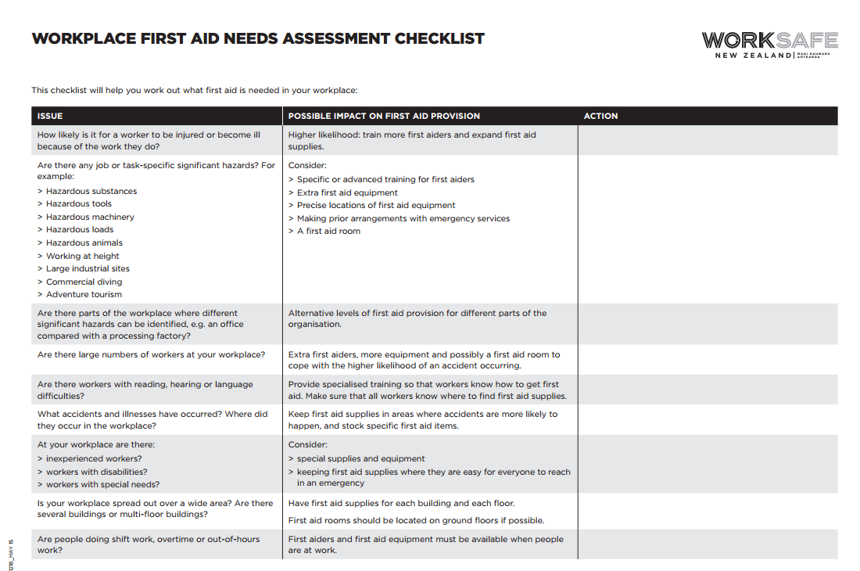
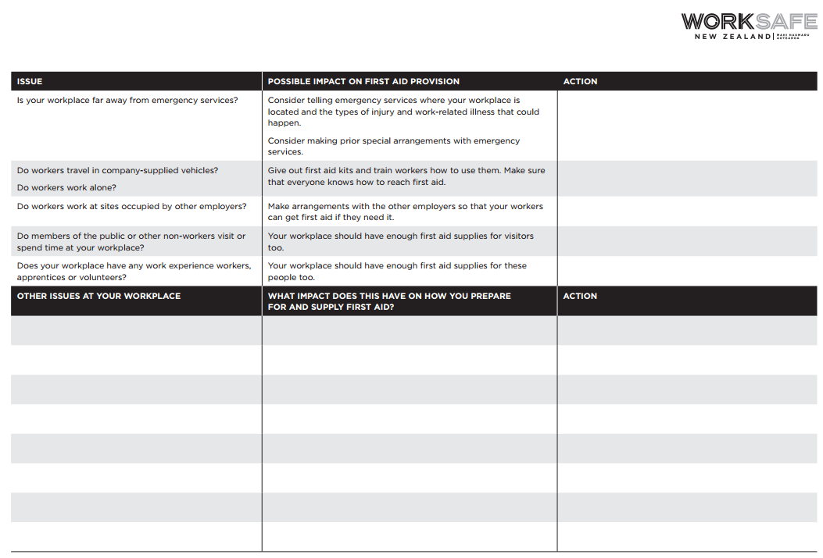

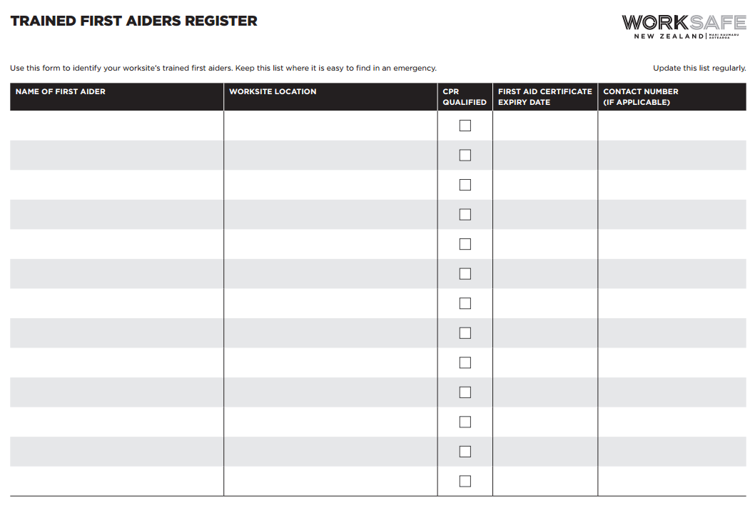

Suggested minimum contents for a workplace first aid kit
- a manual giving general guidance on first aid
- individually wrapped moist wipes or saline solution
- 20 individually wrapped sterile adhesive dressings (assorted sizes), appropriate to the type of work (dressings may be of a detectable type for food handlers)
- two sterile eye pads
- two individually wrapped triangular bandages (sterile)
- clasps or safety pins to tie bandages
- two stretch bandages
- six medium sized, individually wrapped unmedicated wound dressings – approximately 12cm x 12 cm
- two large sterile individually wrapped unmedicated wound dressings – approximately 18cm x 18cm
- two pairs of disposable gloves
- one resuscitation mask.

This is a suggested contents list only, you may want to use equivalent but different items. When you do your Needs Assessment you may identify a need for additional items. This could include, for example:
- scissors
- adhesive strips or band-aids for minor wound dressing
- non-allergic adhesive tape
- disposable aprons
- forceps or tweezers to remove foreign bodies
- individually wrapped moist wipes or saline solution
- plastic bags for waste disposal
- hand sanitiser.
Ideally, these items are stored inside the first aid kit. But if necessary they may be stored separately as long as they are available for use as required.

