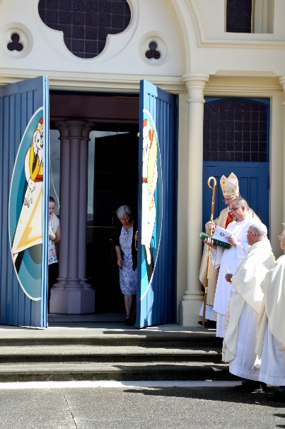

**A PRAYERFUL PEOPLE**

**FOCUS: Mystagogia** – He is Risen Alleluia.

1. Here is another ‘big’ word; it translates as “the unpacking of the mystery”. What mystery?
2. The mystery we have received in baptism and what it means to live as the Risen Body of Christ in our place and time.

* For the early Church, this is the great season, the weeks after Easter, in which we ‘unpack’ what it means for us to have died with Him, been buried with Him, and Risen with Him: and to explain to the newly baptised how we live it in our lives with our brothers and sisters, especially those in need.
* You and I have died with Him on Good Friday, been buried with Him, and risen this Easter. We gather with Him every Sunday, we recognise Him in the breaking of the Bread, and he sends us to baptise, to preach Good News and to serve HIM present in the poor and those in need This is the call of this month, these weeks after Easter, to remove our ignorance, and to send us to feed the hungry!!

**Suggested April Focus:**

**Corporal Works:**  
*Feed the Hungry*

**Spiritual Works:**  
*Instruct the Ignorant*

# Truly, we become that which we receive

*There is a beautiful passage in St. Augustine when he proclaims:*

“If you are the body and members of Christ, then it is your sacrament that is placed on the table of the Lord; it is your sacrament that you receive. To that which you are you respond “Amen” (“yes, it is true!”) and by responding to it you assent to it. For you hear the words, “the Body of Christ” and respond “Amen.” Be then a member of the Body of Christ that your Amen may be true.” (CCC, no. 1396, quoting St. Augustine, Sermo 272: PL 38, 1247)

Our taking part fully in the liturgy of Easter sends us as a community of faith to “witness” in the world. We do this by proclaiming the great “amen” in our day-to-day interactions with others, including during unpredictable and least desired moments.

Our “amen” is seen in day to day life as we live justly and mercifully not only within a comfort zone of friends and family, but also in reaching out in active care for others, such as during a severe economic downturn or times of sudden illness or loss. This is the meaning of our year of Mercy, of our Easter mystery and our baptism; we believe in the power of love seen in the Risen One, so we see Him in our brothers and sisters, and as we see so we have a change of heart, and our change of heart leads us to visit, to feed, to clothe and to free Him in the least of those we live with!

**Newsletter/Bulletin Notices**

Week ending April 03  
Living Resurrected Mercy:

He is risen, and we in exactly the same way as the first disciples: gather as a community, every Sunday, in the Upper Room. When will we see Him, when will we experience his Peace? At heart it is deeply linked to the Year of Mercy, we will see Him when we put our fingers into his hands, into his side, where He is wounded, suffering, being crucified: in one of the least, then we will recognise the Risen Christ. Easter Sunday leads us to serve every day of the week! He is Risen Alleluia, Alleluia, let us follow Him in faith!

Week ending April 10  
Living Mercy:

The world doesn’t want us to preach the message, says the first reading. Where are we going to do it? In our daily lives, ‘they were out fishing’ and they were willing to put out the nets. In the tea room, are we willing to wash the dish, to listen to the one who wants to tell the story yet again? Are we willing to caste the net into the deep, when we are tired and sad? In faith we say, “Yes” and not only do we find a great haul, we meet the Risen Christ!! He is Risen Alleluia, Alleluia, Let us open our eyes to see Him!!

Week ending April 17  
The face of the Lord’s Mercy:

He sent the Good News for all peoples, in every language and race and place. The Risen Jesus is not speaking English and only worshipped in Broadway or Ruahine Street. He speaks many languages and calls all peoples, and then into One Body, One Community! Let us open our eyes, ears and hearts to welcome all our Brothers and Sisters in Christ! He is Risen Alleluia, Alleluia!

Week ending April 24  
We join together to live Mercy and Life:

Here is the most beautiful element, the Body of Christ is us, the Church, gathered; it is HERE that God lives among the human race, in you and me, when we love one another! We are gathered together, for one purpose, to worship God in word and deed, with all our heart and soul and mind; and then to love Him present in our brothers and sisters and those to whom He sends us. HE is Risen , Alleluia, Alleluia, let us serve Him in love!

**Links to Resources**

[**www.pn.catholic.org.nz/mercy**](http://www.pn.catholic.org.nz/mercy)

**The Diocesan site with many resources for prayer and ideas for action, dates and how to make a pilgrimage. There is also a link to the Jesuit website with ideas on the Spiritual works of Mercy**

**Major Events**

* Caritas Challenge April 01-02
* ANZAC April 25