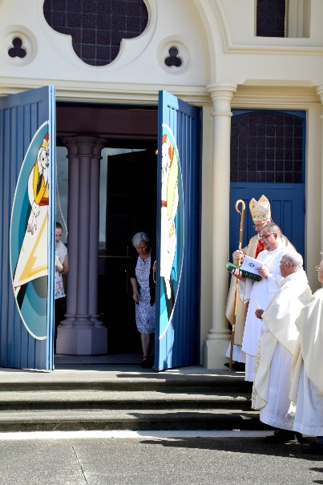

**A PRAYERFUL PEOPLE**

**FOCUS: Lent** - 40 days of walking with the Lord.

We are in the middle of Lent, each year, we have been called to “return” to the Lord in prayer, fasting and almsgiving.

There are two parts to this call:

1. We know that in the gift of Easter we are reborn, we are already one in the Risen Christ, and we will recommit in the great Vigil of Easter;
2. BUT and it is a big but, in the every-day living of our Christian life, we know we fall short, and that we need to “turn again” /metanoia; and follow again

So:

* Give yourself 20 minutes in stillness with the Lord each day of this Lent; open your heart,” be still and know that I am God”.
* Once a week, go without a meal, or each day your latte, and know the space in your heart where the Lord will make His home.
* Take the money from that fast and give it to the poor.

**The works of Mercy – a version by James K Baxter**

*A Cast-Iron Programme for Communal Activity, at Jerusalem, in Crash Pads, or in People’s Homes*

Feed the hungry; Give drink to the thirsty; Give clothes to those who lack them; Give hospitality to strangers; Look after the sick; Bail people out of jail, visit them in jail, and look after them when they come out of jail; Go to neighbours’ funerals; Tell other ignorant people what you in your ignorance think you know; Help the doubtful to clarify their minds and make their own decisions; Console the sad; Reprove sinners, but gently, brother, gently; Forgive what seems to be harm done to yourself; Put up with difficult people; Pray for whatever has life, including the spirits of the dead.

Where these things are done Te Wairua Tapu comes to live in our hearts and doctrinal differences and difficulties begin to banish like the summer snow.

Baxter, James K., and J. E. Weir(ed). *James K. Baxter: Complete Prose*. Vol. 3. Wellington: Victoria UP, 2015. Pp.200-300.

There is a great pdf of this for printing on the diocesan website – [www.pndiocese.org.nz/mercy](http://www.pndiocese.org.nz/mercy)

**Links to Resources**

[**www.pn.catholic.org.nz/mercy**](http://www.pn.catholic.org.nz/mercy)

**The Diocesan site with many resources for prayer and ideas for action, dates and how to make a pilgrimage.**

**Major Events**

* 24 Hours with the Lord – 4-5 March
* Mass of Chrism - 22 March
* Triduum of the Lords Passion, Death and Resurrection - 24-27March
* Caritas Challenge -1-2 April

**Newsletter/Bulletin Notices**

Week ending March 06  
Experiencing Mercy:

In Lent we can use two sets of readings, but both of them say “open your eyes, Look for the one walking toward you, seeking reconciliation, healing, welcome, forgiveness”. We are often blind, we often don’t think the other should be forgiven, but this Year of Mercy tells us that justice, peace and holiness start with ‘looking out for’ the one who thinks they are lost, and running toward them with love and forgiveness

Week ending March 13  
Experiencing Mercy:

Don’t look to the past; don’t hold up the Law to the one who is exposed in public sadness and hurt! Do not condemn! Rather the Lord is doing a new thing, and the new thing is in you and me knowing that in Christ is the love, forgiveness, healing, newness offered to all of creation and humanity. God is offering a new thing through your hands and mine, our words and lives.

Week ending March 20  
Experiencing Mercy:

We come to the heart of this year of Mercy. To follow Christ and to know God’s love and faithfulness is to act humbly, to serve, to die to self, to go with Christ on this walk, his passion and death, in the full hope of God’s love and forgiveness. We are called to speak to the weary, to walk with those unjustly condemned and stand at the foot of the cross as a people who wash feet, and are taken, blessed, broken and given.

Week ending March 27  
Experiencing Mercy:

Jesus Christ is Risen Alleluia, Alleluia. And WE are the witnesses, we are the ones who have eaten and drunk with Him and we proclaim to the world around us: “Nothing can come between us and the love of God made visible in Christ Jesus!!” Nothing, not sin, or death, poverty, or injustice; because we proclaim and live, in our words and deeds, a God of Mercy, love and the fullness of life!