What is a year of Jubilee?
It is a time for a restart, a forgiving of all debt, for rest and reorientation. In the Jewish calendar it was once every 50 years, and the Church has maintained this tradition, of pilgrimage, of opening a Holy door, and of people going to make a new start, a new direction.
There have been a number of Jubilee years in the last century, in addition to the normal cycle of Jubilee, but this coming year is the same call: What is at the heart of our faith? Mercy, forgiveness expressed in our way of life and thinking, and in our actions. To do this we take a year of reflection, of reorientation, and make a new commitment to walk in the way of the Lord in all that we say and do! This is exemplified by the traditional works of Mercy that we will
examine and live out during this year

Corporal Works of Mercy
The Corporal Works of Mercy are these kind acts by which we help our neighbours with their material and physical needs.
- feed the hungry
In Matthew’s gospel the Lord is very clear : our lives, our humanity, is ‘judged’ on a simple criteria : “what you do to / for one of these my brothers and sisters you do to /for me!” The actions the Lord calls us to are simple but challenging and are contained in these works of mercy.
- give drink to the thirsty
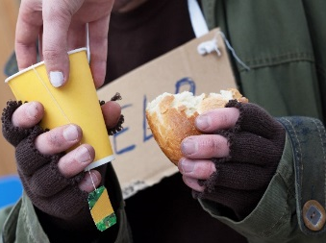
- clothe the naked
- shelter the homeless
- visit the sick
- visit the imprisoned
- bury the dead

Spiritual Works of Mercy
The Spiritual Works of Mercy are acts of compassion, as listed below, by which we help our neighbours with their emotional and spiritual needs.
- counsel the doubtful

To perform the corporal works of mercy demands that our heart be in the right place. This is the spiritual formation of our personality that is expressed in our way of acting. We are called to listen, to form, to pray, to forgive : ourselves and others: this creates us in the Spirit of Christ
- instruct the ignorant
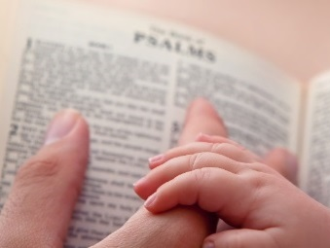
- admonish sinners
- comfort the afflicted
- forgive offenses
- bear wrongs patiently
- pray for the living and the dead

Links to Resources
www.im.va - Official Vatican site for the Jubilee Year.

www.pndiocese.org.nz/mercy
The Diocesan site where we will post resources and ideas as the year progresses.

Pilgrimage to the Diocesan Cathedral
Pope Francis has asked, as part of the Jubilee Year celebrations that a Holy Door be set aside for pilgrimage in the diocesan Cathedral.
Everyone is invited by Bishop Charles and the Cathedral Parish to make a pilgrimage to the Cathedral and through the Holy Doors during the Jubilee of Mercy. Information on booking your group’s visit will be provided soon.
Individuals will be able to make a pilgrimage visit any day!!
Major Events

Tuesday, 8 December 2015 – Opening of Jubilee Doors at St Peter’s, Rome. Suggestion of simple Liturgy to finish preparations for the year and to pray for the year ahead.
Sunday, 13 December 2015 – 9.30am Mass and diocesan opening of Holy Doors for Jubilee Year – Cathedral of the Holy Spirit. All invited to join the Celebration to begin this extraordinary year.
4/5 March 2016 – 24 hours with the Lord All are called to prayer and commitment to acts of mercy
Sunday, 13 November 2016 – closing of the Holy Door at the Cathedral
Sunday, 13 November 2016 - Sunday of Christ the King 2016, closing of the Jubilee year in Rome
Newsletter/Bulletin Notices

Week ending November 8
Preparing for the Jubilee of Mercy: We are being called by Pope Francis to join him in a year of Jubilee, in which we are reoriented toward the heart filled with mercy, and hands that give life without counting the cost. The call to each of us is to give of our very self, the little we have, as a gift to be offered to those in greater need as a sign of our love and thanks to the Lord. Let us prepare for the Jubilee in prayer asking “what is the gift that I have to offer my neighbour?”.
Week ending November 15
Preparing for the Jubilee of Mercy: the call of this Sunday’s readings is that we do not know the day or the hour. That means that we are called to understand that every moment is the hour, this is the hour, this is the day in which we are called to turn to the Lord, to be instructed, to forgive, to inform, so that we might act in simple acts of feeding, visiting, welcoming, forgiving and embracing in love and truth. www.pndiocese.org.nz/mercy
Week ending November 22
Preparing for the Jubilee of Mercy: we pray, in the Our Father, “your kingdom come” and we are called to respond in the coming year by saying: your kingdom come in us by our responding in simple lives of forgiveness and actions of mercy. Let us prepare for the Jubilee year and the coming of the kingdom. www.pndiocese.org.nz/mercy

Week ending November 29
Preparing for the Jubilee of Mercy: Today we start both a new liturgical year, the time of advent, and the final preparations towards a year of Jubilee. The call in all is to simplicity, to justice and to a strengthening of our hearts. Let us commit to a year of reorientation, in which we are formed in the likeness of Christ, simple, merciful, forgiving and acting for and with those in need. www.pndiocese.org.nz/mercy

